Project Proposal

System for recommending decks to a user

**By: Marko Vukotić**

The Problem:

Motivation:

Every *Yu-Gi-Oh!* deck has it's unique art style, play style and certain level of difficulty. This system is dedicated to solving that problem. People have different tastes and this system will enable users to find a perfect deck for them.

Yu-Gi-Oh! game:

Yu-Gi-Oh! is a game that consists of decks with cards. Cards inside **main** decks are Monsters, Spells and Traps. Each deck can have extra-deck filled with monster cards. Extra-Deck consists of Fusion, Synchro, XYZ and Link monsters.

Monsters have **types**: Aqua, Beast, Beast-Warrior, Cyberse, Dinosaur, Divine-Beast, Dragon, Fairy, Fiend, Fish, Insect, Machine, Plant, Psychic, Pyro, Reptile, Rock, Sea Serpent, Spellcaster, Thunder, Warrior, Winged Beast, Wyrm and Zombie.

Monsters have **sub-types**.

Monsters have levels/ranks: 1-12.

Monsters also have attributes: Light, Dark, Fire, Water, Wind, Earth and Divine Beast.

Spells and Traps share same sub-types: Normal and Continuous. Spells also have: Field, Ritual, Quick and Equip. Traps also have Counter traps type.

**The Deck** as an archetype consists of cards that are connected to each other. Card are connected via **Name, Artworks (Art is directly connected to the monster type. Machine type monster will not look as an Fish type monster.) and their Effects (These cards support each other.)**.

Problem overview:

User will be providing type of creatures he likes by it's type (Type is directly connected to artworks of the cards eg. If user likes robots he will choose *Machine* type and system will recommend several strategies that are machines). Also user will be able to say what kind of playstyle he likes and what kind of deck mechanic he likes to use. User can also say if he wants to use Extra-Deck or not and if he wants he can choose monster types in the Extra-Deck. Difficulty of play that user inputs is rated 1 between 12 stars.

Usually there is no recommend system in Yu-Gi-Oh! Games. There is only card search option where you add card by card to your deck. Users are often overwhelmed by sheer amount of cards and decks that can be built. That’s why we need a recommend system for users based on their likings and preferences.

The system:

Expected system operation:

* **Input:** User enters all required information to the system. User enters: Type, Playstyle, Extra-Deck mechanic and Difficulty of play.
* **Output:** Several decks that fit users criteria.
* **Knowledge Database:** System will have Decks database, Playstyle database and Extra-Deck database.

Rules:

**Difficulty:**

How hard deck is to pilot.

* Easy (1 - 3 Stars)
* Medium (4 - 6 Stars)
* Hard (7 - 9 Stars)
* Master (10 - 12 Stars)

**Monster Types:**

Family of cards monsters are tied to. They are directly related to looks of a card.

* **Aqua, Beast, Beast-Warrior, Cyberse, Dinosaur, Divine-Beast, Dragon, Fairy, Fiend, Fish, Insect, Machine, Plant, Psychic, Pyro, Reptile, Rock, Sea Serpent, Spellcaster, Thunder, Warrior, Winged Beast, Wyrm and Zombie.**

**Monster Sub-Types:** There are special monsters in the game that have special sub-types. Those types are: **Normal, Effect, Fusion, Synchro, Pendulum, XYZ, Link, Token, Tuner, Ritual, Toon, Union, Spirit, Gemini and Flip.**

**Each of this sub-types can be connected to the difficulty of play:**

* **Easy:** Normal, Effect, Ritual, Toon, Union, Flip
* **Medium:** Fusion, Link, Gemini
* **Hard:** Synchro, XYZ, Tuner
* **Master:** Pendulum, Spirit

Now we can have **forward-chaining**: Users selected max difficulty will favor decks that are that difficulty or under. Example: User selected Medium difficult decks, and then the system will favor decks with sub-types that are Easy and Medium. If user doesn't select any sub-type all sub-types are favored equally.

**Extra-Deck Types:**

Extra-Deck monster have also **types** that are mentioned above but also have their special sub-type. They are strong side monsters that boost the deck strength but also increase difficulty of play.

* Fusion - Purple card; It's made by merging several monsters into one.
* Synchro - White card; It's made by merging tuners and non-tuners.
* XYZ - Black card; It's made by overlaying monsters with same levels.
* Link - Blue card with arrows; It's made by sending monsters from the field to graveyard.

**Deck Playstyle:**

Each deck has its unique playstyle based on cards that are incorporated. Same archetype can be played on several different playstyles.

* Beatdown/Aggro - Deck focused on constant offense at the opponent.
* OTK - Explosive deck focused on one turn kill (finishing opponent with one battle).
* Control - Deck oriented on slow pace and controlling flow of the game.
* Lock - Locking your opponent of using cards.
* Burn - Deck focused on inflicting effect damage.
* Combo - Deck focused on long turns, using huge resources of deck and long combos with cards.
* Stun - Deck that negates opponents cards and targets crucial opponents cards.
* Backrow/Defense - Deck oriented on traps and huge defensive monsters.
* FTK - Rare and very hard decks to play that have goal of beating opponent on first turn.
* Mill - Decks focused on destroying opponents deck. When opponent doesn't have cards to draw he automatically loses.

Rules Details:

* Difficulty Rule: If user selects easy to use decks the system will give favor to decks that have *Easy* difficulty. The system will have same behavior for all difficulties. If user has not selected preferred difficulty the system will favor all decks. **Calculation**: current_score + 0.5.
* Monster Type Rule: User can select up to four (0 - 4, zero represents all types so user doesn't care about looks of the deck and all decks are equally considered) types when searching. Decks that fall into these types gain score equal of types they represent (eg. *Raidraptors* archetype are winged-beast monsters but they look also like machines so they fall into two type categories: Winged-Beast and Machine; In code they will have list attribute in model that consists of these two types.).

Decks gain score up to number of types they have:

**0.** User selected no types so all types will be considered.

**Calculation**: current_score

**1.** User selected one type that he likes. **Calculation**: current_score + 0.5

Since user has selected only one type the system will look for types that are printed on the card.

**2. 3. 4.** User selected several types that he likes. For every type that deck fits (In cards artwork) in criteria it's better ranked.

**Calculation**: current_score + 0.3 * i, i ∈ [ 2, 3, 4 ]

**This applies for rules 1-4:** Now since monsters have sub-types, if user hasn't selected preferred difficulty *current_score* stays the same. But if user has selected preferred difficulty the system will favor types with sub-types that are in selected difficulty (**Forward-Chaining**).

**Calculation:** current_score + 0.1

* Extra-Deck Rule: User can choose (0 - 4) currently available extra-deck types that he wants featured in the deck. When zero is selected all decks get same score. **Calculation**: current_score. When user selects one or more extra-deck types that he wants score increases, but when deck has **all** extra-deck options user chose it gets bonus 0.1 point.

**Calculation**: current_score + 0.2 * j, j ∈ [ 1, 2, 3, 4 ]

current_score + 0.1, eg. User choose 2 types and deck has those 2 types, that deck gets bonus.

* Playstyle Rule: User can choose zero or one playstyle. When zero is chosen all decks are favored equally and user doesn't mind playing any playstyle in the game. **Calculation**: current_score.

When one playstyle is selected, decks that run that playstyle are favored. **Calculation**: current_score + 0.5

Recommendation by system example:

User A likes machines and wants to build a machine deck.

User B likes machines and dragons and wants to build a deck.

User C likes dragons and wants to build a deck.

User D likes warriors and wants to build a deck.

Scenario 1:

User A selects *Machine* type. Selects all *Playstyles* and selects all *Extra-Deck* types.

The system recommends to him all *Machine* decks in the database.

Scenario 2:

User A selects *Machine* type. Selects *OTK Playstyle* and all *Extra-Deck* types.

The system recommends to him *Cyber Dragons* and *Earth Machines*.

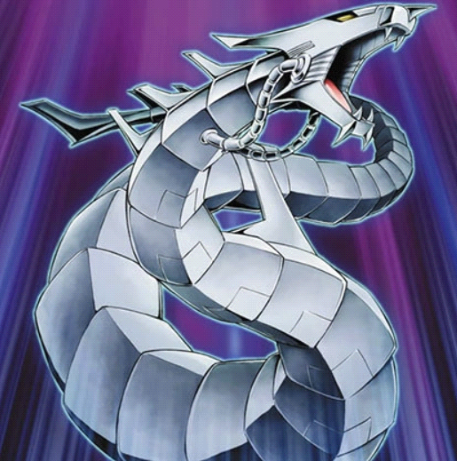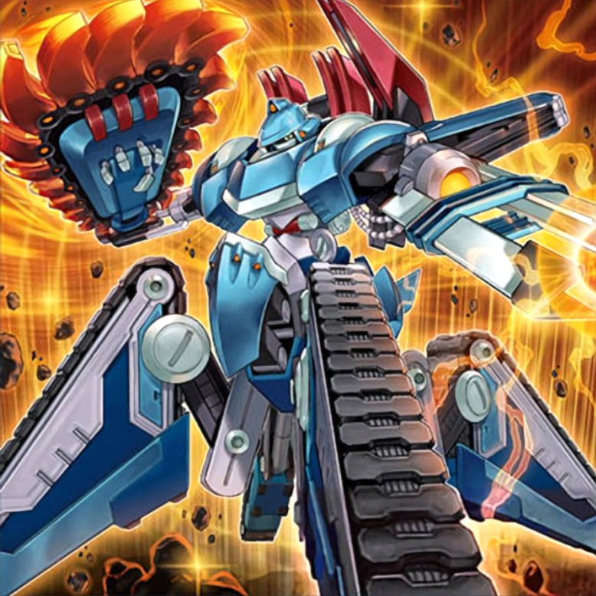

These archetypes for example have the *OTK Playstyle* and are machines so they were recommended by the system. Since user has chosen all *Extra-Deck* types no decks were filtered.

Scenario 3:

User B selects *Machine* and *Dragon* type. Selects all *Playstyles* and selects all *Extra-Deck* types.

The system recommends to him *Cyber Dragons* since they look like mechanical dragons.



Scenario 4:

User C selects *Dragon* type. Selects all *Playstyles* but selects *Synchro Extra-Deck* type.

The system recommends to him *Stardust* since they are dragon archetype and use synchro mechanic.

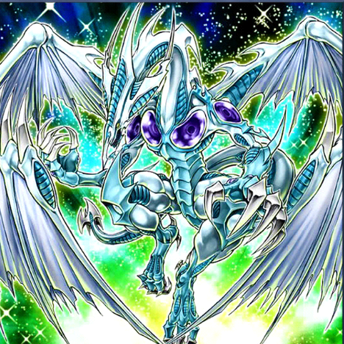

The system has not recommended *Red-Eyes* (Fusion), *Galaxy-Eyes* (XYZ) nor *Dragon-Link* (Link) archetypes because they do not use Synchro Extra-Deck mechanic even though they are all dragons.

Scenario 5:

User D selects *Warrior* type. Selects *Combo* playstyle and selects all *Extra-Deck* types.

The system recommends to him *Synchro Warriors* since they use *Combo* playstyle and are warriors.

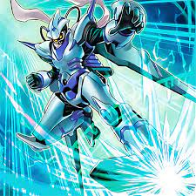

Because user selected *Combo* playstyle system hasn't recommended decks that don't play that style even though those decks have warriors.